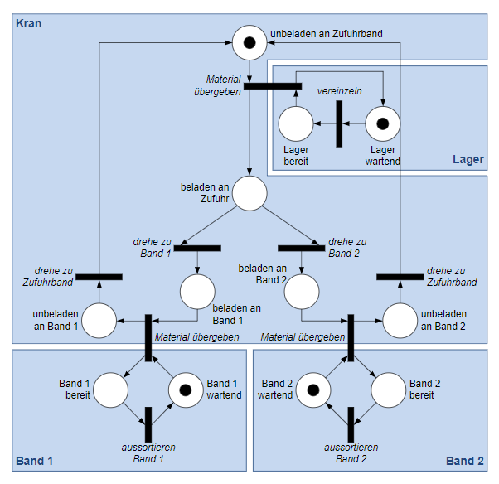

**Error description**: When transfering the mark from the state „beladen an Zufuhr“ to the following transition („drehe zu Band 1“ or „drehe zu Band 2“), the possibility of the mark being assigned to left transition (Band 1) and right transition (Band 2) is random, rather than alternate.

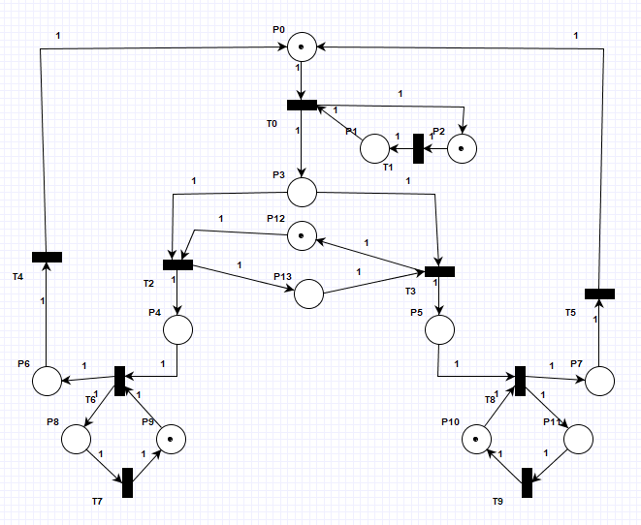

Modification proposal: In order to enable transitions „drehe zu Band 1“ and „drehe zu Band 2“ to be activated alternately, two control states (p12 and p13) are added between these two transitions. The two control states share a mark. When the transition corresponding to the control state with mark is activated, the mark will be transfered to another control state to make sure that, the another transition will be activated at the next loop.